Jaypee Institute of Information Technology, Noida.

Subject: Unix Programming Lab

LAB TEST Marks:20

Set(A)

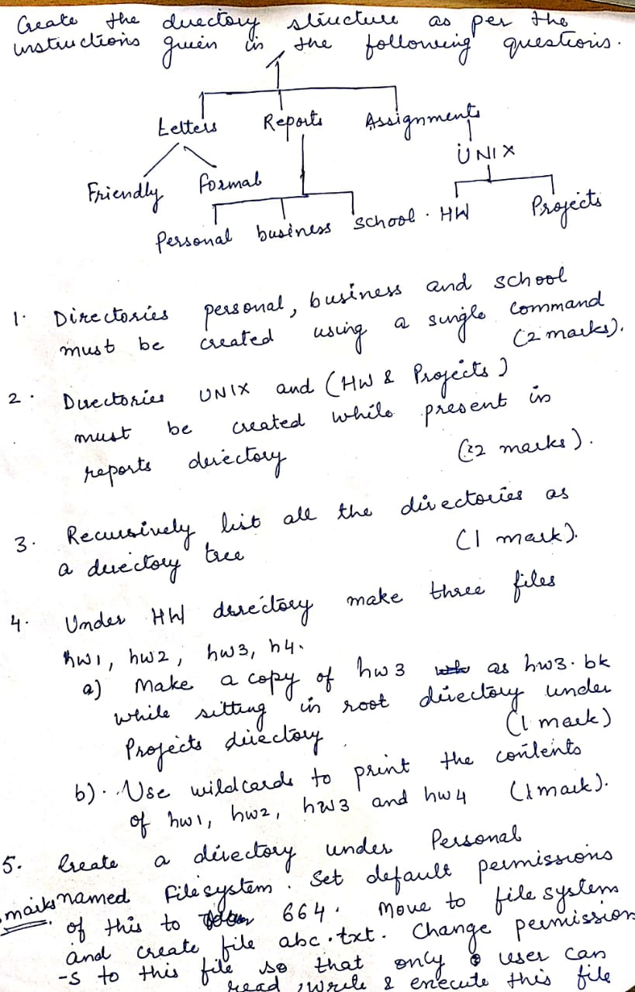

**[C373.2]**

(2)

(a) Write a command to list all the files in current working directory for the month of August. [C373.2] (5Marks)

(b) Create a text file with at least 10 lines. Issue a single command to display the lines 5 to 8 from that file. [C373.2] (5Marks)

Set(B)

1. Create 5 files in current working directory. Write a command to search the contents of all of the files in current directory and display the total number of lines in them that contain the string “Linux” but not the string “UNIX”. [C373.2] (4Marks)

2. Create files with following names

users-111.list, users-1AA.list, users-22A.list, users-2aB.txt, users-2ba.txt, users-111.txt, users-1AA.txt, users-22A.txt, users-2AB.txt, users-2bA.txt, users-11A.txt, users-1AB.list, users-2aA.txt, users-2ba.list, users-12A.txt, users-1AB.txt, users-2AB.list, users-2bA.list [C373.2]

(a) Display all files whose name starts with “users-”, followed by a number, a lower case letter or number, then a number and ends with any number of occurrences of any character or number. (6Marks)

(b) Display all filenames beginning with “users-”, followed by a number, a lower or upper case letter or number, then a lower or upper case letter and ends with any number of occurrences of any character or number. (4Marks)

(c) Display all filenames starting with “users-”,followed by any number of characters or numbers, followed by a number twice, and followed by any number of characters or number. (6Marks)